User Profile Display
Users  - Primary  - Kolavo user  - Secondary  - … | Phase 1
Intended Outcome
- Every user can see and feel their own identity within Kolavo, including their basic personal data and the communities they belong to.
- Users are able to view a clear list of all communities they have joined or applied to, with membership status (member/admin) and registration status (in process, accepted, rejected) visible for each.
- This unified profile experience helps users recognize their journey in Kolavo, strengthens their sense of belonging, and makes it easy to track their participation across communities.
Links
- …
- …
- …
- …
- …

Introduction
User Profile Display in Kolavo is designed to give every user a clear and unified view of their identity and journey across communities. On their profile page, users see their basic personal information—including full name, email, WhatsApp number, domicile, birth date, and gender—alongside a dynamic list of all communities they are associated with. For each community, users can quickly see their status: whether they are an accepted member, an admin, or if their membership application is still in process or was rejected.

This profile display is more than just a static page; it reinforces the user’s sense of who they are in the Kolavo ecosystem, gives them an easy way to track their “community footprint,” and increases engagement by making next steps and achievements visible at a glance.

Product Requirement
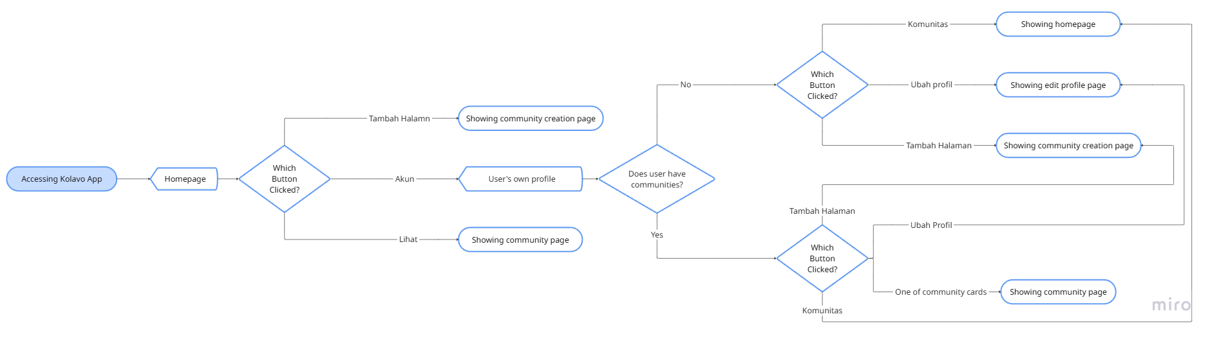
Viewing User's Own Profile Flow

No | User story | Scope | Acceptance Criteria
1 | As a Kolavo user, I want to view my basic profile information, so that I know and recognize my identity on the platform. | User Profile Display (Basic Info) | - Profile page displays:  - Profile picture  - Full name,  - domicile (city/province/country).  - Info shown is pulled from initial registration to Kolavo.  - Profile page is triggered by clicking Akun (User Profile Picture).
2 | As a Kolavo user, I want to see a list of all communities I am associated with, so I can track my participation in Kolavo. | Community List Section in Profile Page | - Below the user info section, display users’ communities list.  - Each community includes a community logo, community shortname, which are also clickable and direct to each community page.  - All communities where the user has applied, been accepted, is a member, or is an admin appear in the list.  - List is readable and responsive across devices.
3 | As a Kolavo user, I want clear status indicators for each community (member/admin, pending, accepted, rejected), so I know my relationship to every community. | Community Membership & Application Status | - Each community entry in the list displays:  - Membership role:  - Admin  - Member  - Application status:  - Pending  - Accepted  - Rejected  - Status is indicated by clearly labeled.  - Users can quickly see whether their application is approved, their role, or why access might be restricted.  - No admin notes, approval detail, or member ID is displayed.  - If no communities are found, a friendly empty state is shown.
4 | As a Kolavo user, I want to find the edit profile button, so I know where to trigger the edit profile page easily. | Edit profile button | - Edit profile button is shown distinctly  - When it is clicked, it directs to the user edit profile page.

Design Requirement
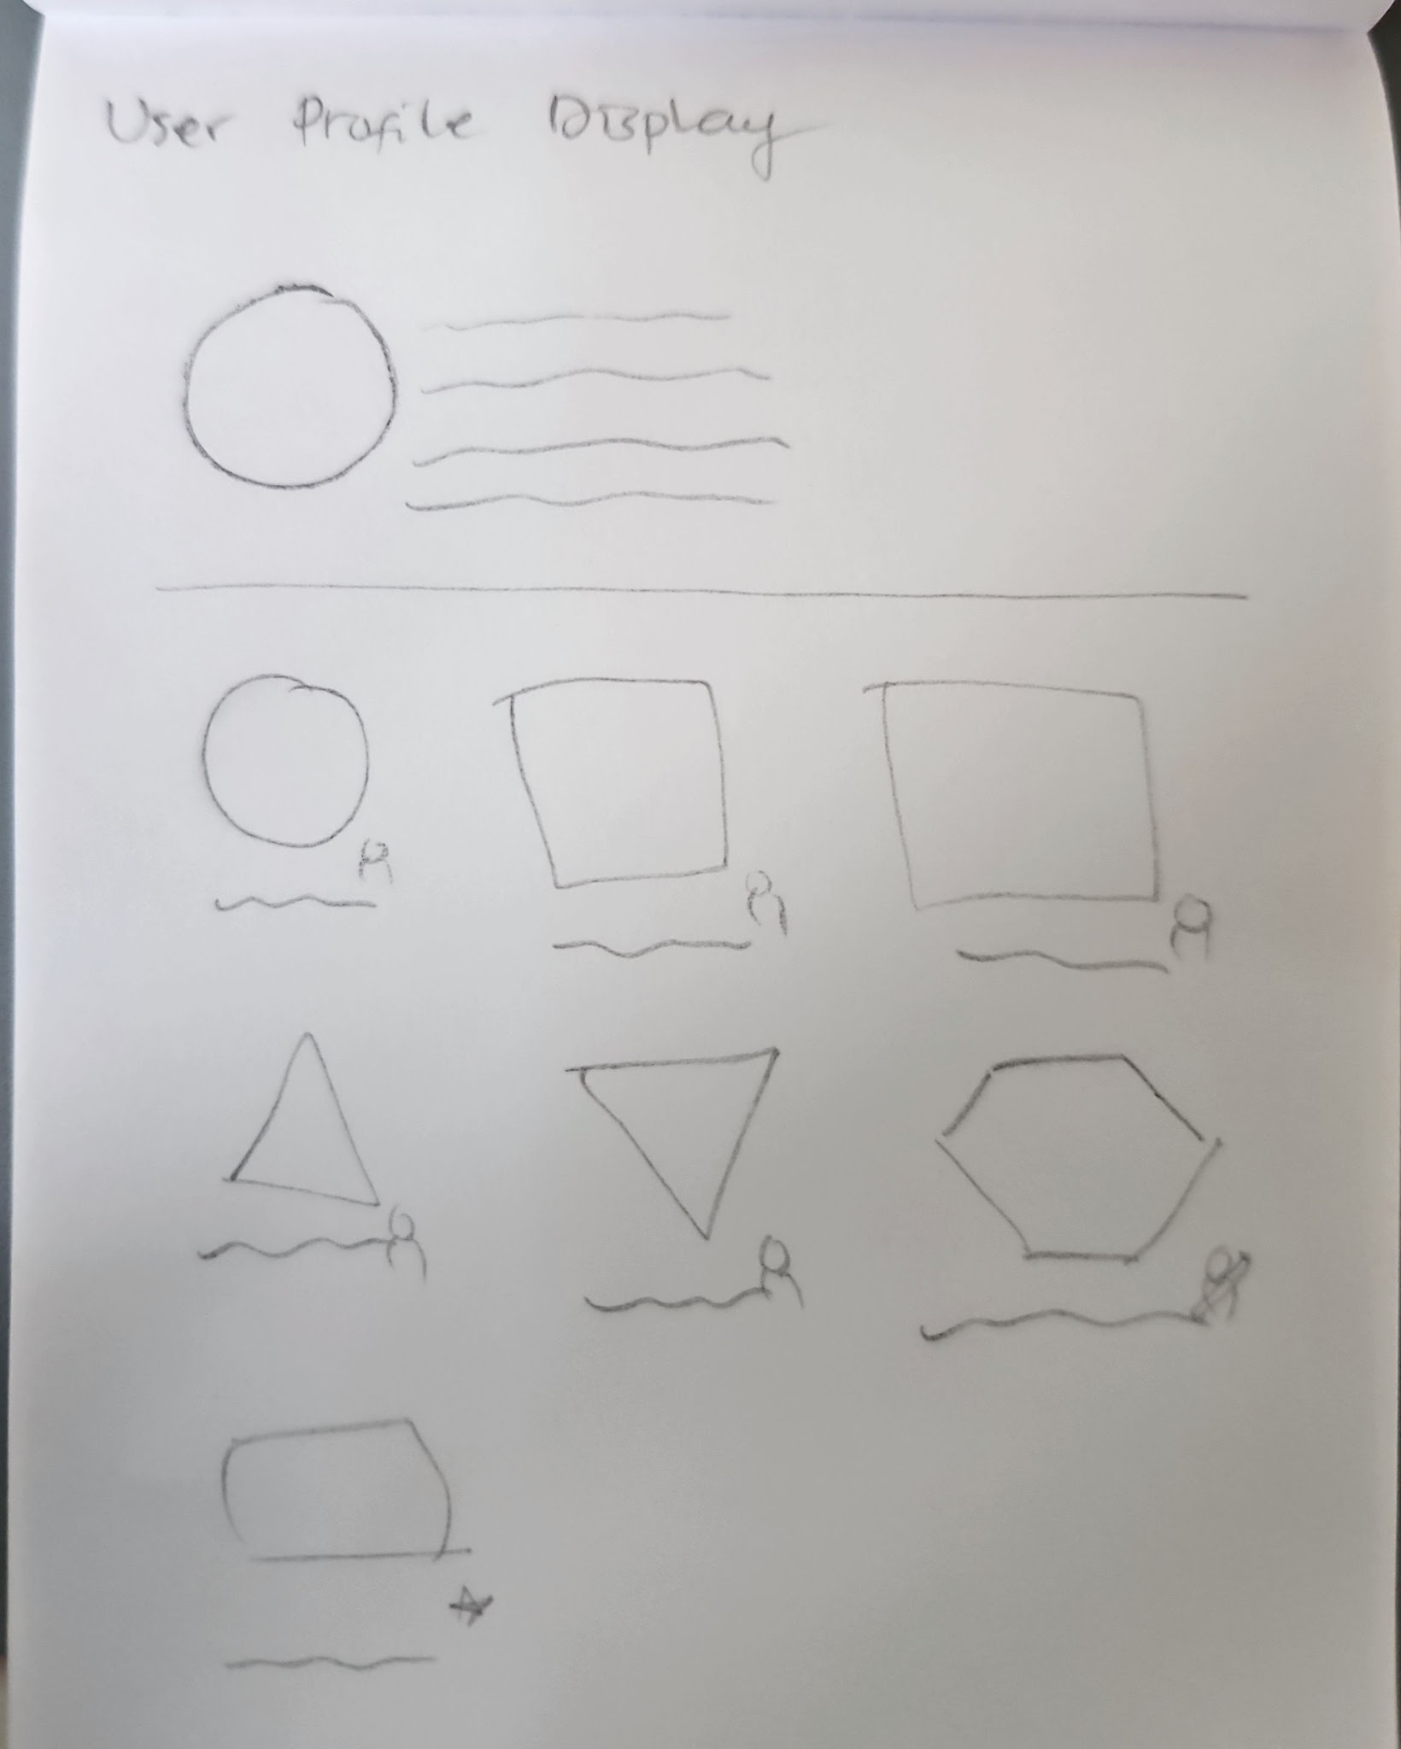

Account Menu
Design Intent | To allow users to open their profile page.
Content / Copy | - Account:  - Profile not setup: Akun  - Profile setup: Profile Picture
Visual Requirement
Interaction Behavior | - Directs to user profile page when account button is clicked
Acceptance Criteria

User Profile Page
Design Intent | To ease users recognize their personal identity not related to their communities on the platform.
Content / Copy | - User profile picture  - User fullname: [nama lengkap]  - Domicile: [city], [province], [country flag]
Visual Requirement
Interaction Behavior
Acceptance Criteria

Edit Profile Button
Design Intent | To ease user triggering the profile setup page when needed
Content / Copy | - Edit Profile Button: Ubah Profil
Visual Requirement
Interaction Behavior | - Clicking edit profile button directs to edit profile page
Acceptance Criteria

User Community List
Design Intent | To ease users tracking their communities participation in Kolavo
Content / Copy | - Section heading: Daftar Komunitasmu  - Community card empty:  - Section subhead: Belum ada komunitas yang kamu ikuti.  - Helper text: Yuk, mulai eksplor komunitas yang sudah ada, atau buat komunitas barumu sendiri!  - Community card filled:  - Community logo  - Community shortname  - Membership role  - Admin: Admin  - Member: Anggota  - Application status:  - Pending: Menunggu  - Accepted: Diterima  - Rejected: Ditolak  - Community page status:  - Drafted: Draf  - Published: Terbit
Visual Requirement
Interaction Behavior | - If no communities registered, show empty state  - Clicking Jelajahi Komunitas directs to public community list page  - If users joined to more than one communities, the order are:  - Admin  - Drafted  - Published  - Member  - Accepted  - Pending member  - Rejected as member  - Community page opens as community card is clicked
Acceptance Criteria

Engineering Requirement

Questions

